In the name of God

Producer:  
Mehrab Atighi

Subject:  
Comparison of production time of two random numbers with normal standard distribution with Box Mueller method and Polar method.

Date:

12/7/2020

Supervisor:  
Dr.Seyed Noorullah Mousavi

issue:

Compare the production time of two random numbers with normal standard distribution with Box Mueller method and Polar method by repeating ${20}^{9}$ times and calculate the time to produce each number of random numbers in each method and draw the corresponding diagram. They.

Solve:

According to the alg of each methods we run some codes in R program and we can see the result:

> rm(list = ls())

> memory.limit(size = 9999999999999)

[1] 1e+13

> n=9

> N=10^n

> #the Box Muller alg:

> x<-c()

> y<-c()

> i=1

> end_time.Box.muller<-c()

> for(j in 1:n){

+ end_time.Box.muller[j]<-system.time(while(i!=10^j){

+ U1<-runif(1)

+ U2<-runif(1)

+ x[i]<-sqrt(-2*log(U1))*cos(2*pi*U2)

+ y[i]<-sqrt(-2*log(U1))*sin(2*pi*U2)

+ i=i+1

+ })[3]

+ }

Error: cannot allocate vector of size 11.5 Gb

Timing stopped at: 1691 313.9 4149

> end_time.Box.muller

[1] 0.00 0.00 0.00 0.03 0.38 3.60 34.78 333.11 7367.98

> #pollar alg:

> n=9

> N=10^n

> end_time.pollar<-c()

> i=1

> for(w in 1:n){end_time.pollar[w]<-system.time(while(i!=10^w){

+ s=2

+ while (s>1) {

+ U3<-runif(1)

+ U4<-runif(1)

+ V1<-(2*U3)-1

+ V2<-(2*U4)-1

+ s<-V1^2+V2^2

+ }

+ x[i]<-sqrt((-2*log(s))/s)*V1

+ y[i]<-sqrt((-2*log(s))/s)*V2

+ i<-i+1}

+ )[3]}

> end_time.pollar

[1] 401.55 0.04 1.04 0.78 1.68 6.90 36.12 370.53 3657.87

> data.frame(end_time.pollar,end_time.Box.muller)

end_time.pollar end_time.Box.muller

1 0.00 0.00

2 0.04 0.00

3 1.04 0.00

4 0.78 0.03

5 1.68 0.38

6 6.90 3.60

7 36.12 34.78

8 370.53 333.11

9 3657.87 7367.98

>

> plot(1:9,end_time.Box.muller, ylab = "time" , xlab = "20^n" ,type = "b" , col="red")

> points(end_time.pollar,type = "b" ,col="blue")

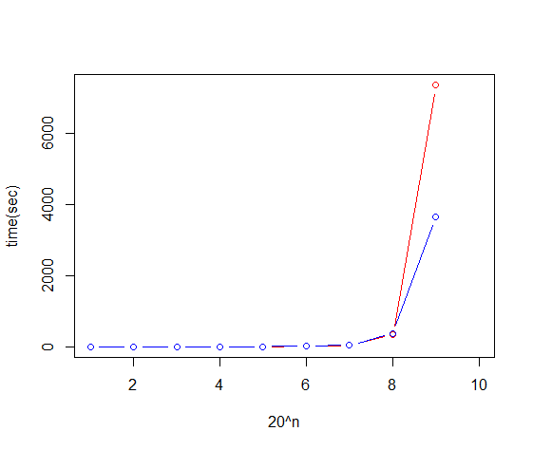

We can see that to some extent both methods work almost side by side with very little difference, but when the number of numbers we generate increases, the average time it takes for numbers to be generated by the polar algorithm is much lower than the average time when numbers are generated by the method. Müller boxes are produced.